1. **Agenda**:
   1. How to secure sensitive info such as
      1. Password,
      2. Folder location,
      3. Email configurations.
2. **Solution**: Encrypt such properties and save into the properties file.
3. Spring Cloud helps us to achieve this with minimum configurations.
4. How?
   1. Spring Cloud Config Server will decrypt it before sending to the Config Client.
5. Make minimum configurations inside Config Server to inform Config Server to encrypt and decrypt a few properties.
6. **Key**: 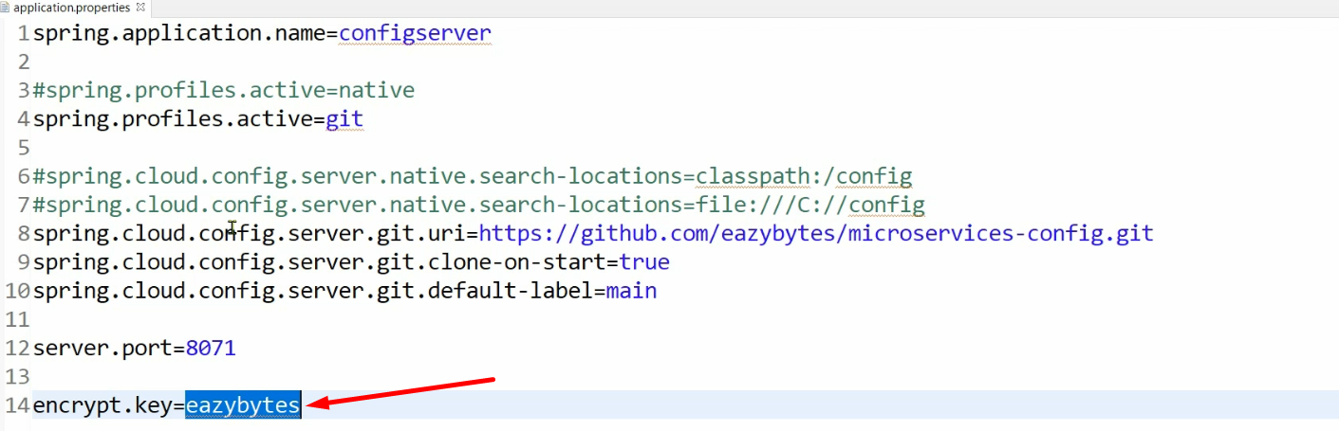
   1. This will be used to encrypt and decrypt properties.
   2. The key must be a complex key when reading it.
   3. It must be stored either as environmental variable or in some secure location.
   4. As soon as you put this property, your Config server will expose two end-points to outside world.
      1. One to encrypt value.
      2. Second to descript value.
7. 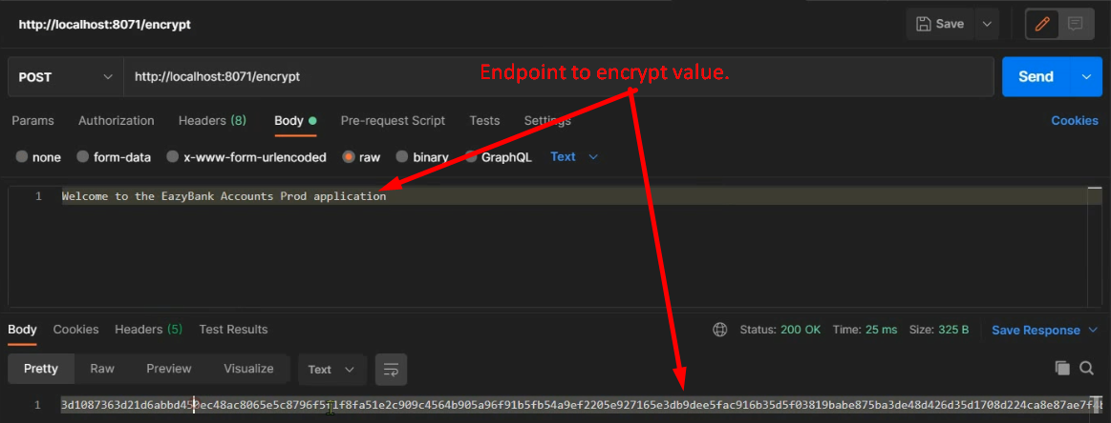
8. 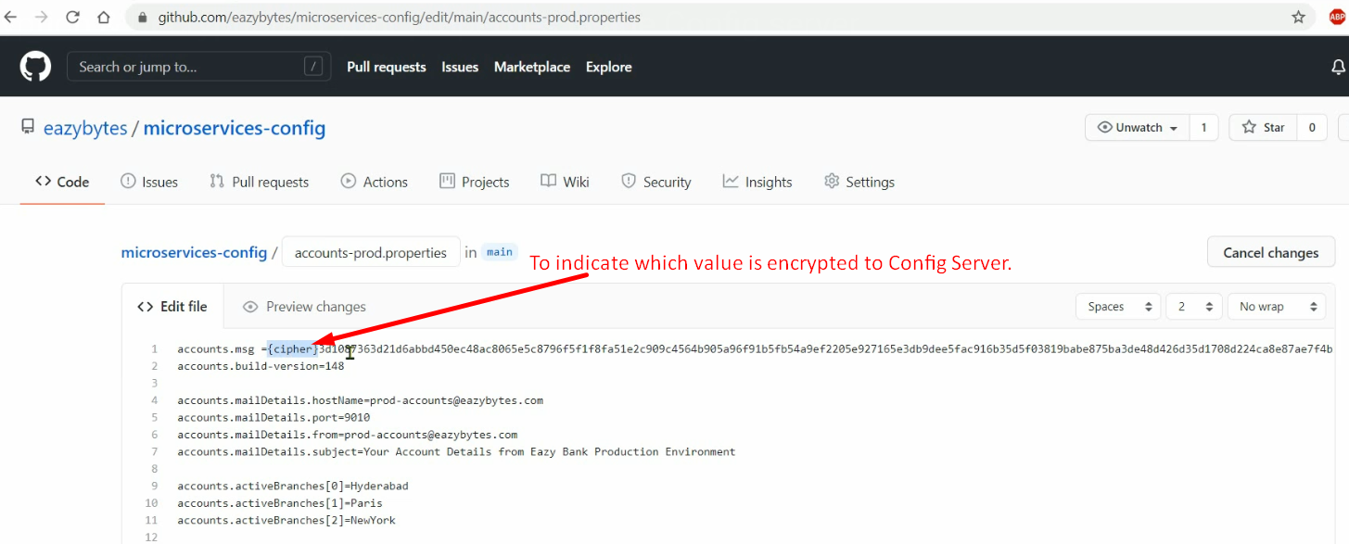
9. 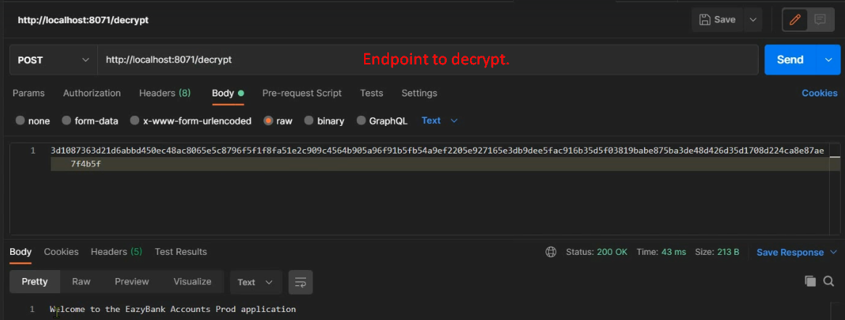
10. 